**7th Grade Supply List 2021-22**

**Rosa Parks Community School**

Dear Parents,

To help ensure a successful educational year for the upcoming 2021-2022 school year at Rosa Parks Community School, the 7th Grade team needs your child to come prepared with the following tools.

* ***5 – 2 pocket folders***
* ***2 – composition notebooks***
* ***1 – 1 inch - 3 ring binder with paper***
* ***Pens and Pencils (including color ink pens)***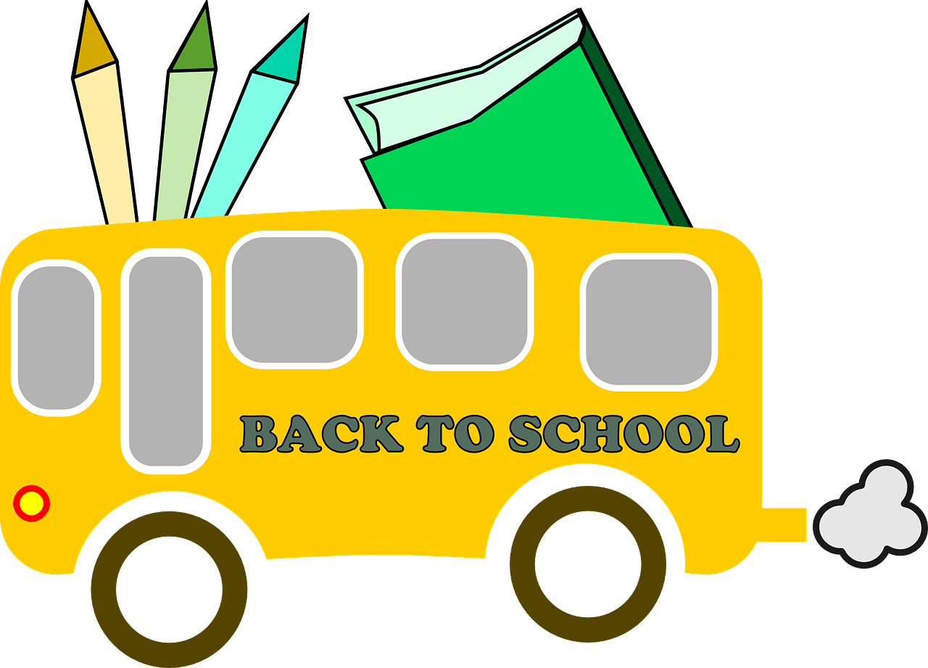
* ***Index Cards***
* ***Post it notes***
* ***Dry erase markers***
* ***Tissues***
* ***Copy paper - 2 packs***
* ***Hand sanitizer***
* ***Paper towels***
* ***Disinfectant wipes***

Another component of success for 7th grade is the communication between parents and teachers. Email communication is strongly encouraged and email addresses can be found on the Rosa Parks Community Website located at <http://www.orange.k12.nj.us/Domain/558> , look under the faculty tab.

We look forward to working with you and your child, and having a successful 2021-2022 school year.

Sincerely,

The 7th Grade team at Rosa Parks Community School